**Kickstart on Creating a Data Science Virtual Machine on Azure Portal**

This demo will help in configuring a virtual machine on azure from both classic and resource manager portal of azure.

**Pre-requisites:**

* Azure subscription.
* To create a Microsoft Data Science Virtual Machine, you must have an Azure subscription. If you don’t have check with Azure free trial subscription [Get Azure free trial](http://azure.com/free).

**Follow the below steps now:**

Step – 01:

Open up the azure portal using www.portal.azure.com ,the portal will look like the below image.

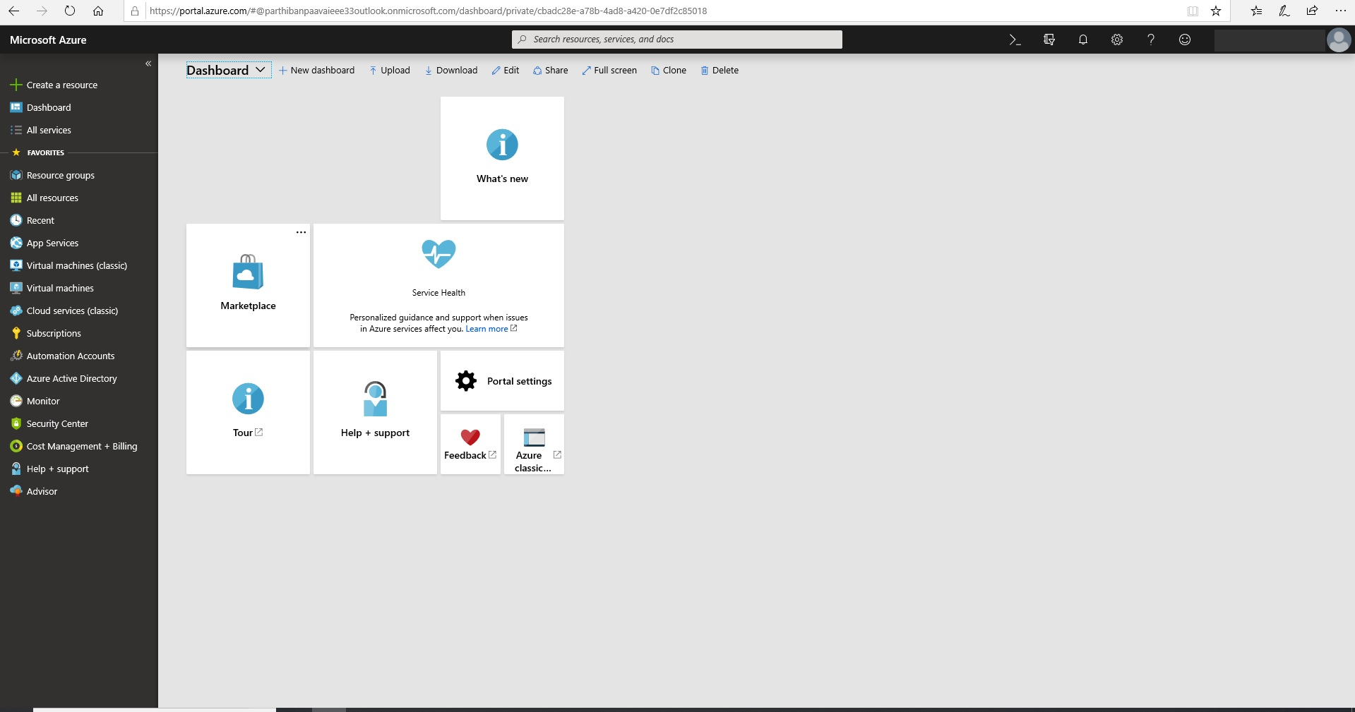

Step – 02:

In the Azure portal, Select the **Create** button at the bottom to be taken into a wizard and followed by "AI+Machine Learning " and then Choose the "Data Science Virtual Machine - windows 2016".

Step – 03:

The Microsoft Data Science Virtual Machine requires input. The following input is needed to configure each of the steps shown on the right of the figure

**Basics**:

**Name**: The name of the data science server you're creating.

**VM Disk Type** Choose **SSD** or **HDD**.

**User Name**. The admin account ID to sign in.

**Password**. The admin account password.

**Subscription**. If you have more than one subscription, select the one on which the machine is to be created and billed.

**Resource Group**. You can create a new one or use an existing group.

**Location**. Select the data center that's most appropriate. For fastest network access, it's the data center that has most of your data or is closest to your physical location.

**Size**. Select one of the server types that meets your functional requirements and cost constraints. For more choices of VM sizes, select **View All**.

**Settings**:

**Use Managed Disks**. Choose **Managed** if you want Azure to manage the disks for the VM. If not, you need to specify a new or existing storage account.

* Select your Subscription and create a resource group or select your old resource group, if you want to create new resource group, click create new and give a resource group container name.

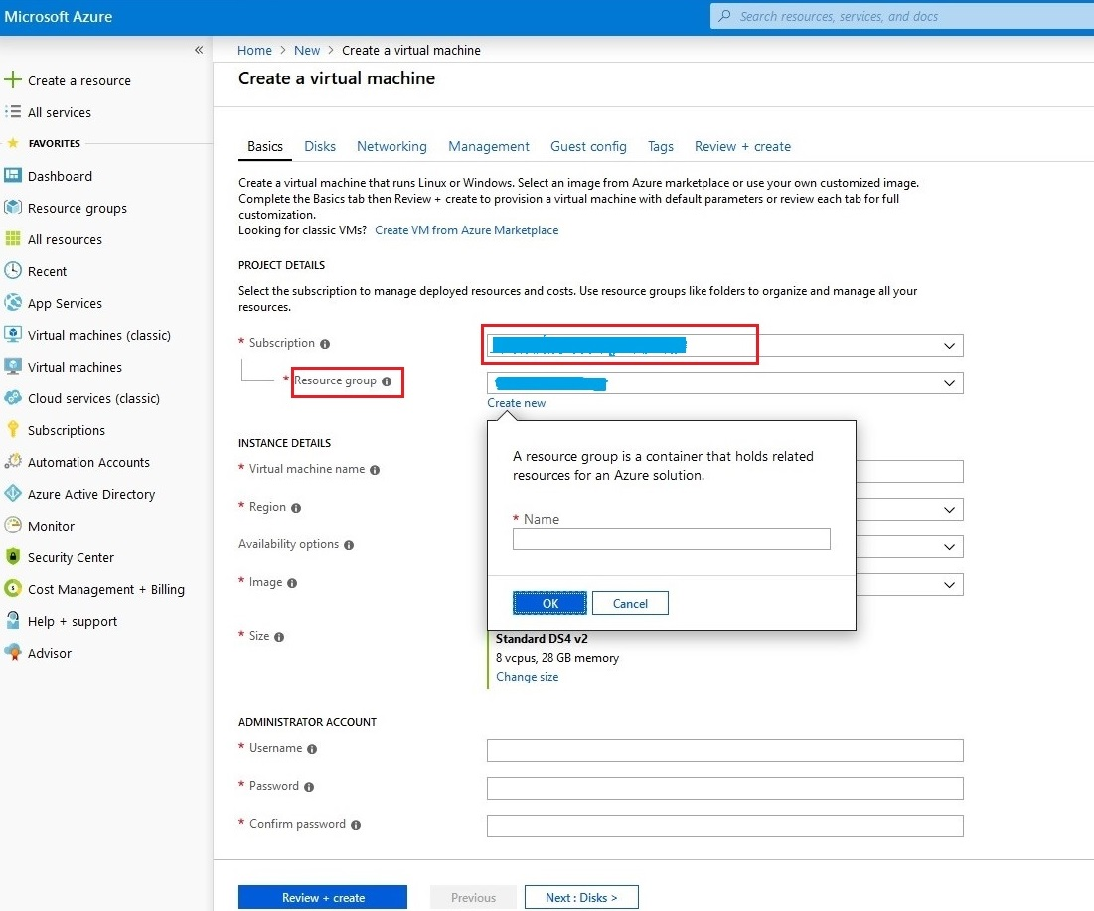

* Next, select the instance details like VM name, Region, Availability options, images, size.

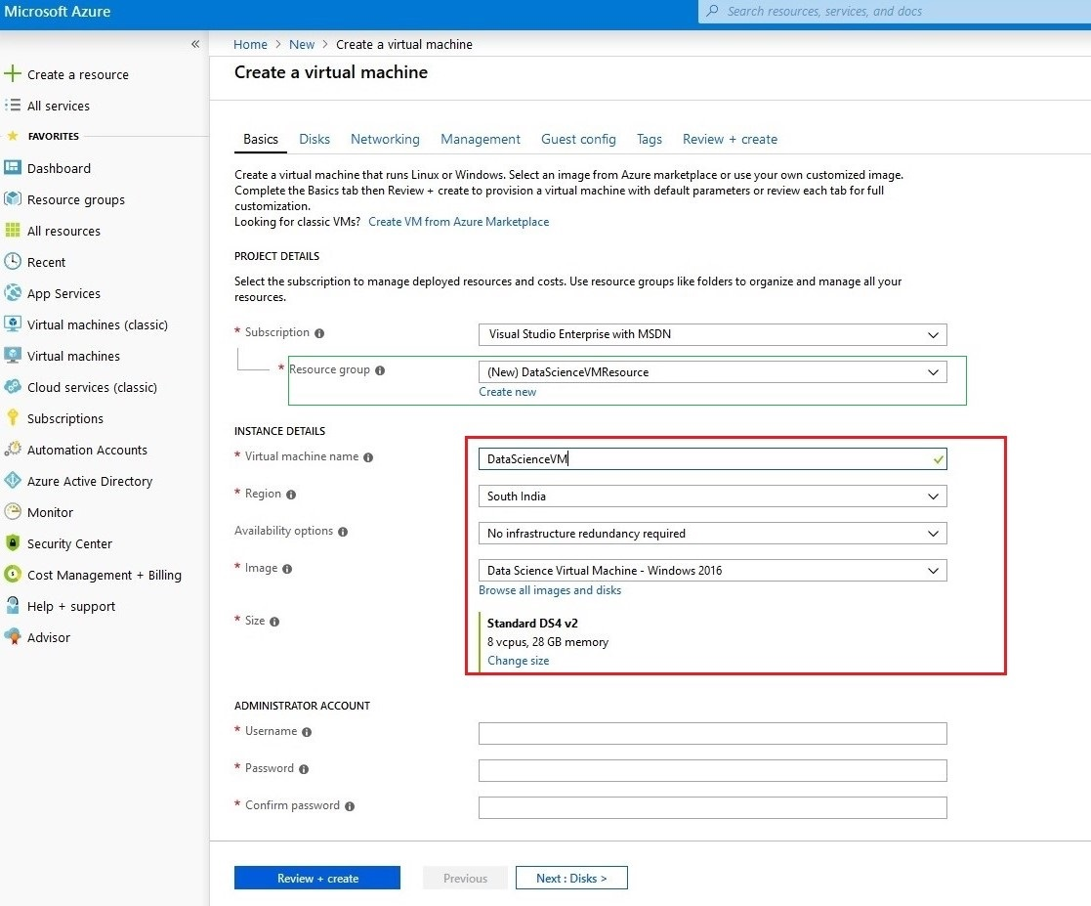

* Select the Image from the blade named “Data Science Virtual Machine - Windows2016”.

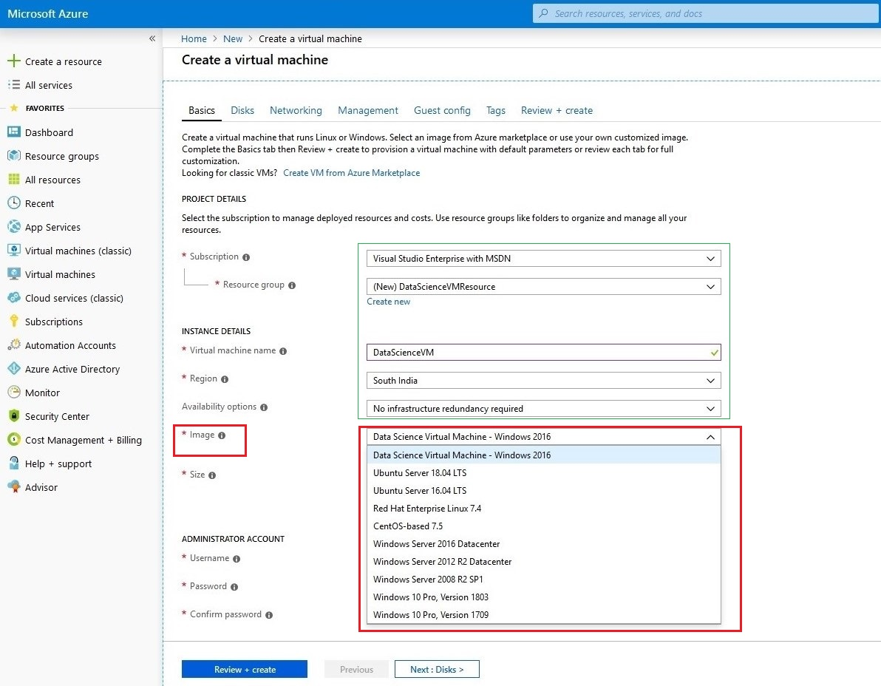

* Select the Size from the server types that meets your functional requirements and cost constraints.

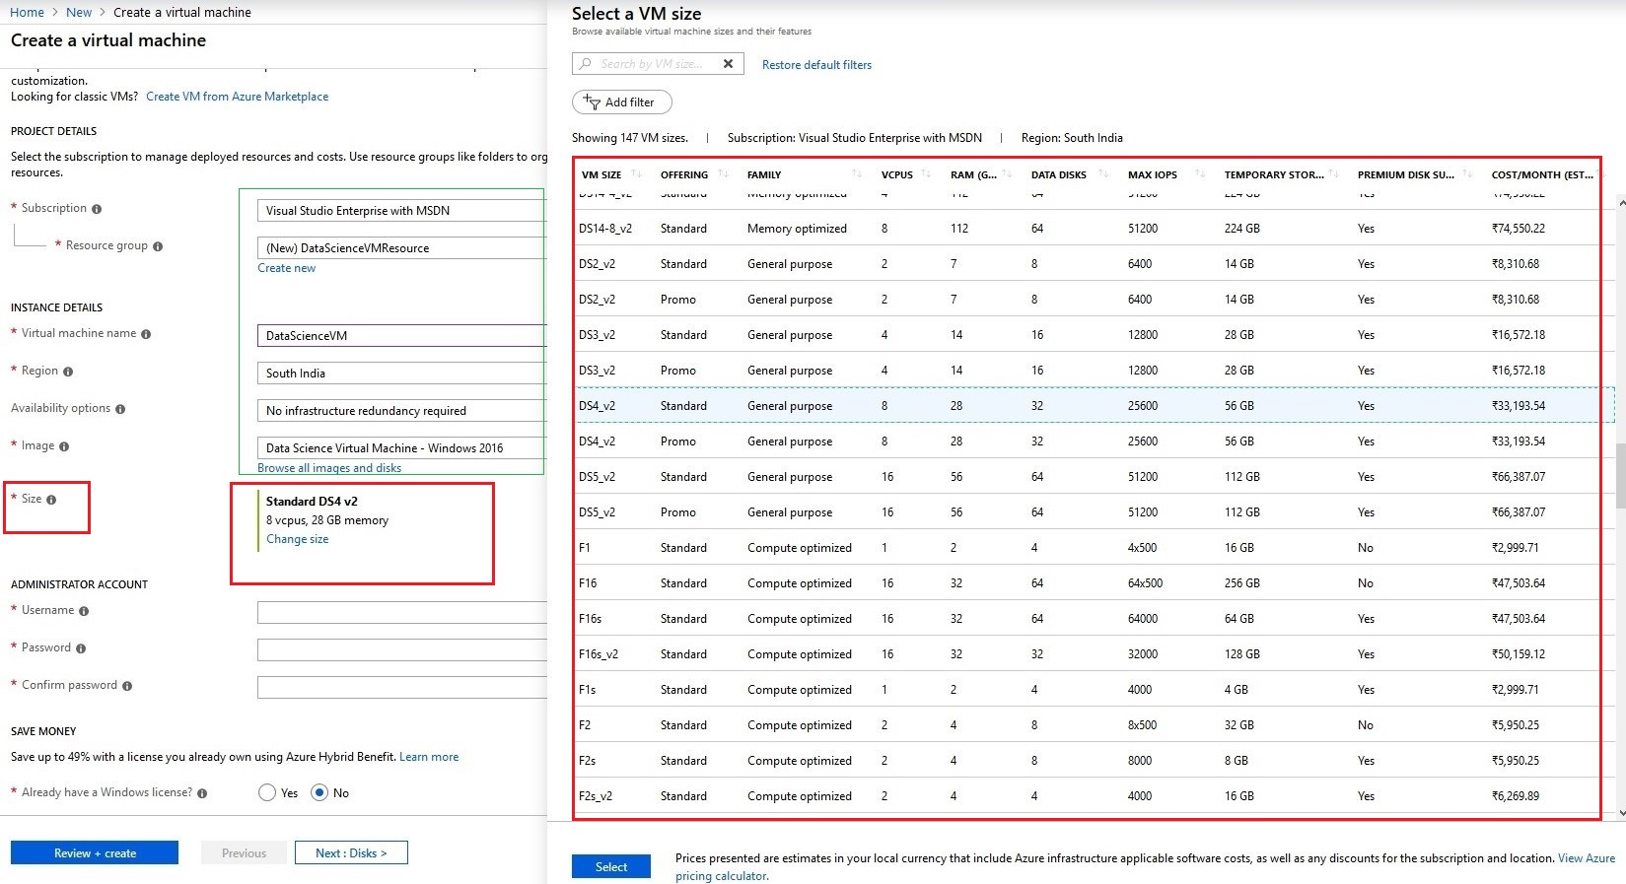

* Next, give the administrator account details like VM username and password and click the Next button to configure VM disk type.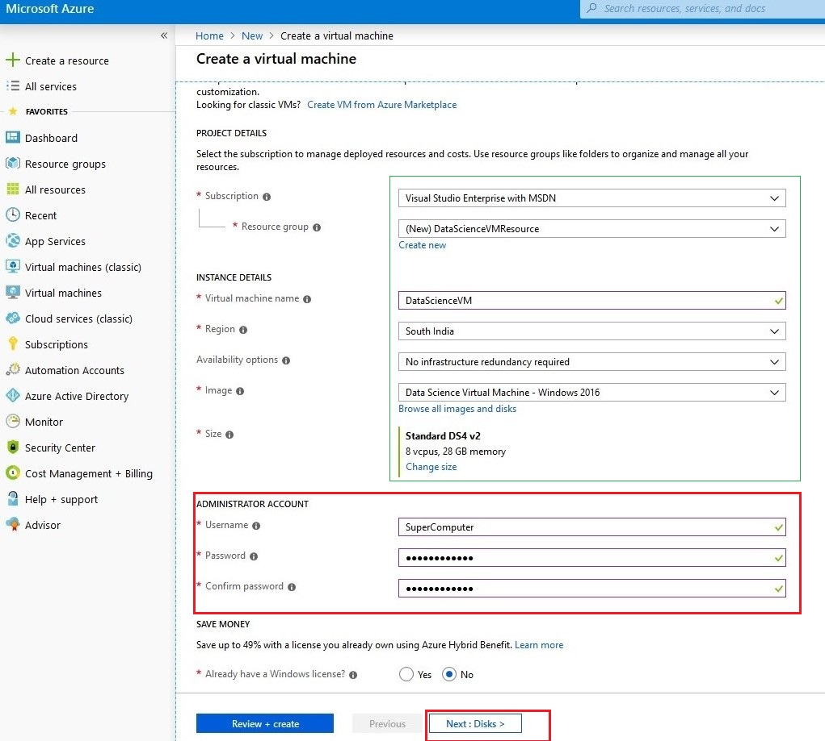
* Select the VM OS disk type Choose **SSD** or **HDD**. For an NC_v1 GPU instance like NVidia Tesla K80 based, choose **HDD** as the disk type. Then click, Create and attach a new disk.

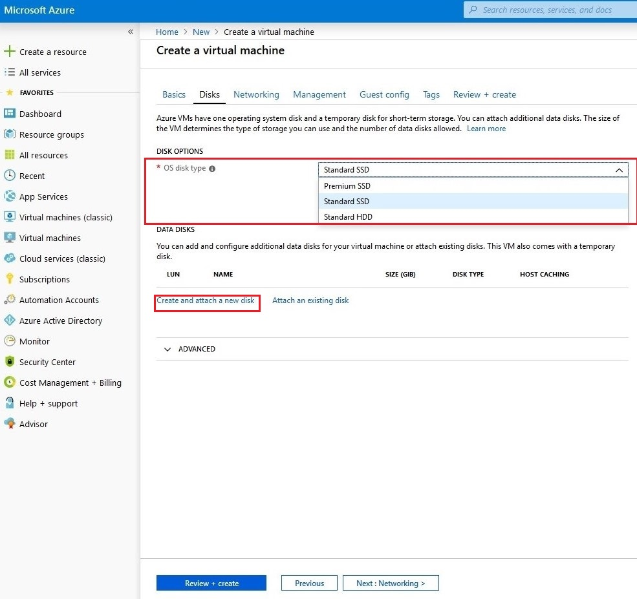

* Create a new disk for VM Storage and Select the disk type for storage and provide name for your VM data disk.

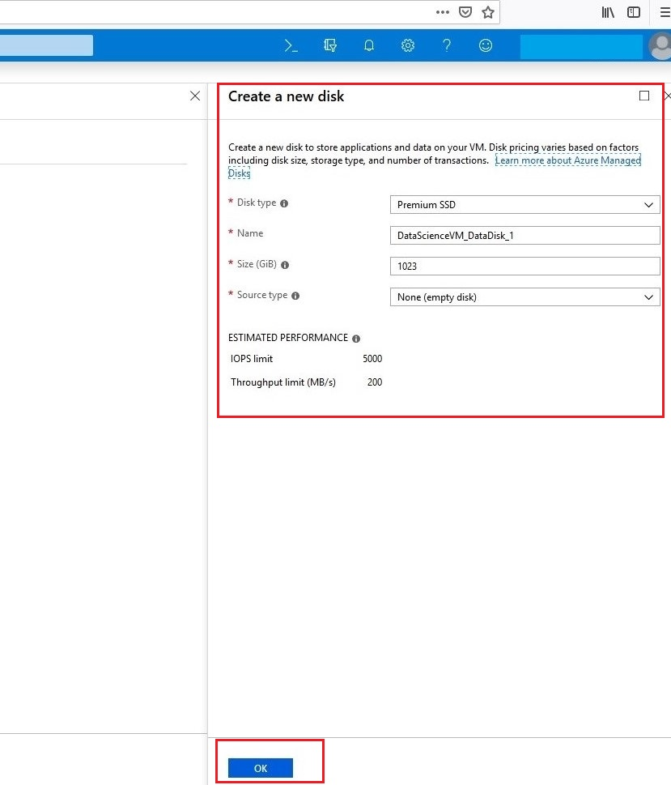

* Then, Create a virtual network for VM and provide virtual network and public ip ,Network security group and after click the button Next to set management activity for VM.

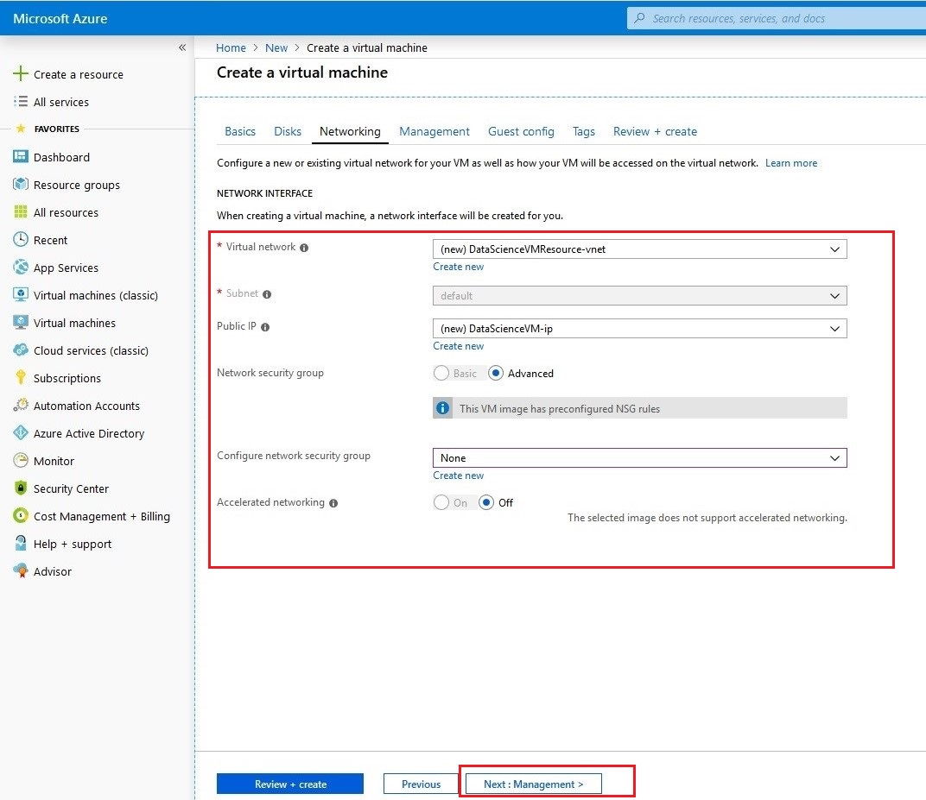

* In this blade, configure your VM monitoring options like Auto shutdown, shutdown time, get notification through mail before shutdown and create a new storage account for VM usage, click the button "Create new” to create storage account. click the button Next to Guest config for VM.

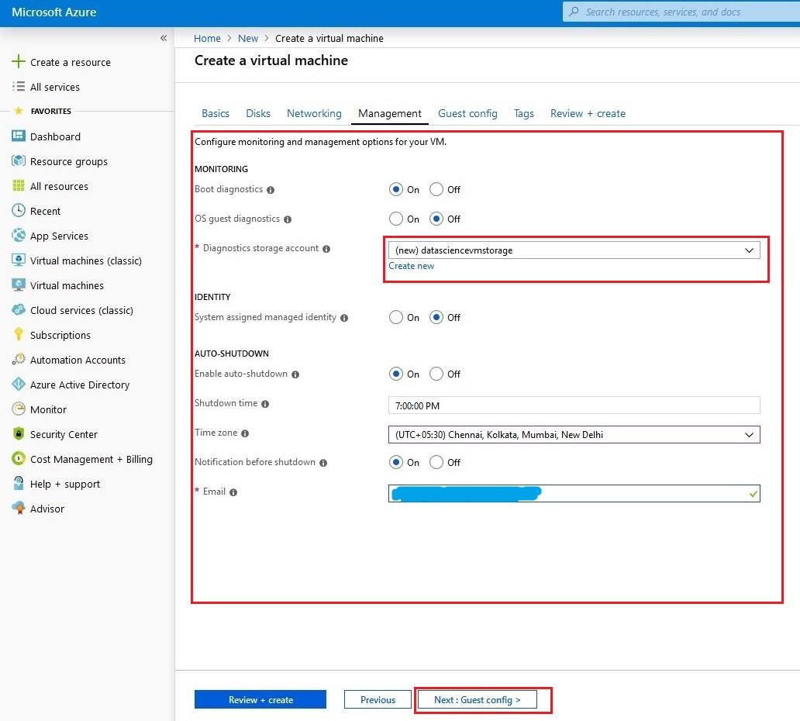

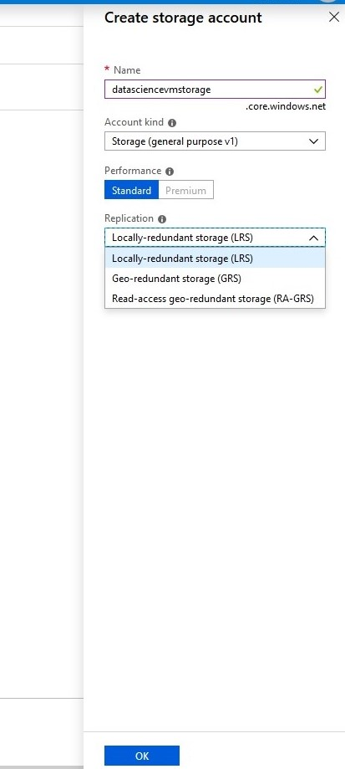

* In this blade, don't change anything because for your VM all are predefined on all aspects if you want any additional extensions select from an extension install. Then press button Next for Tags.

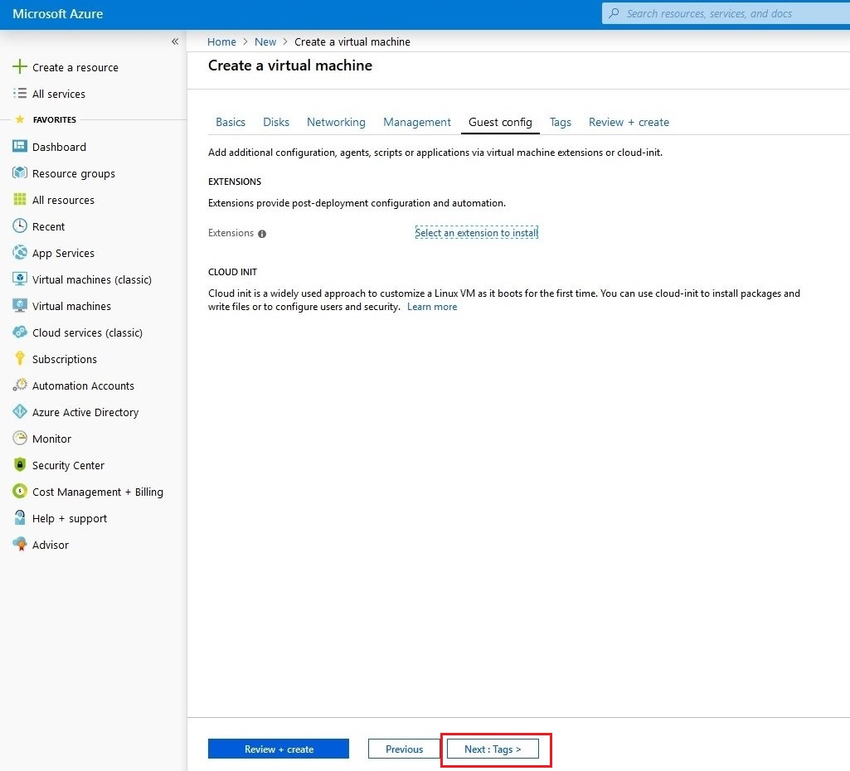

* In this blade, don't change anything because for your VM all are predefined. Then press button Next for Review and create your Data science VM.

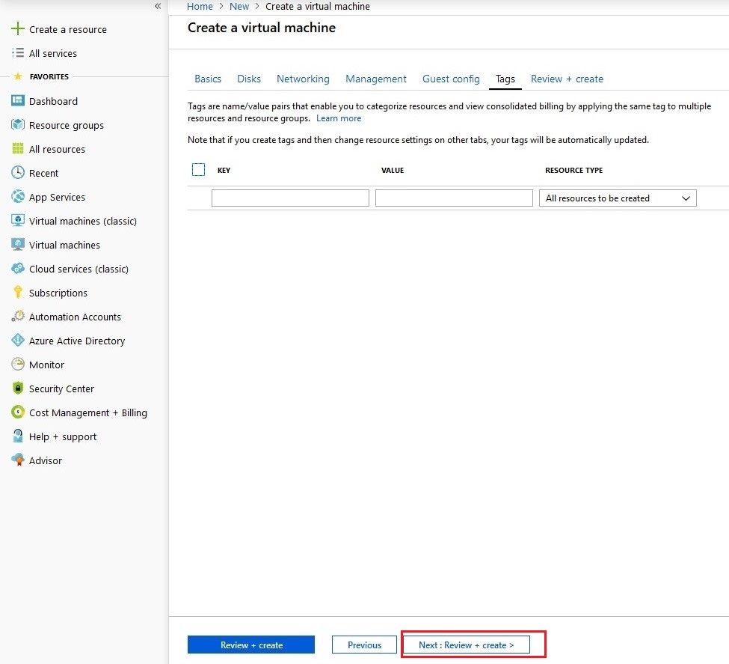

* Finally, it gives the detailed report of your Data science VM.Then Press button "Create" to create your Data Science Virtual Machine.

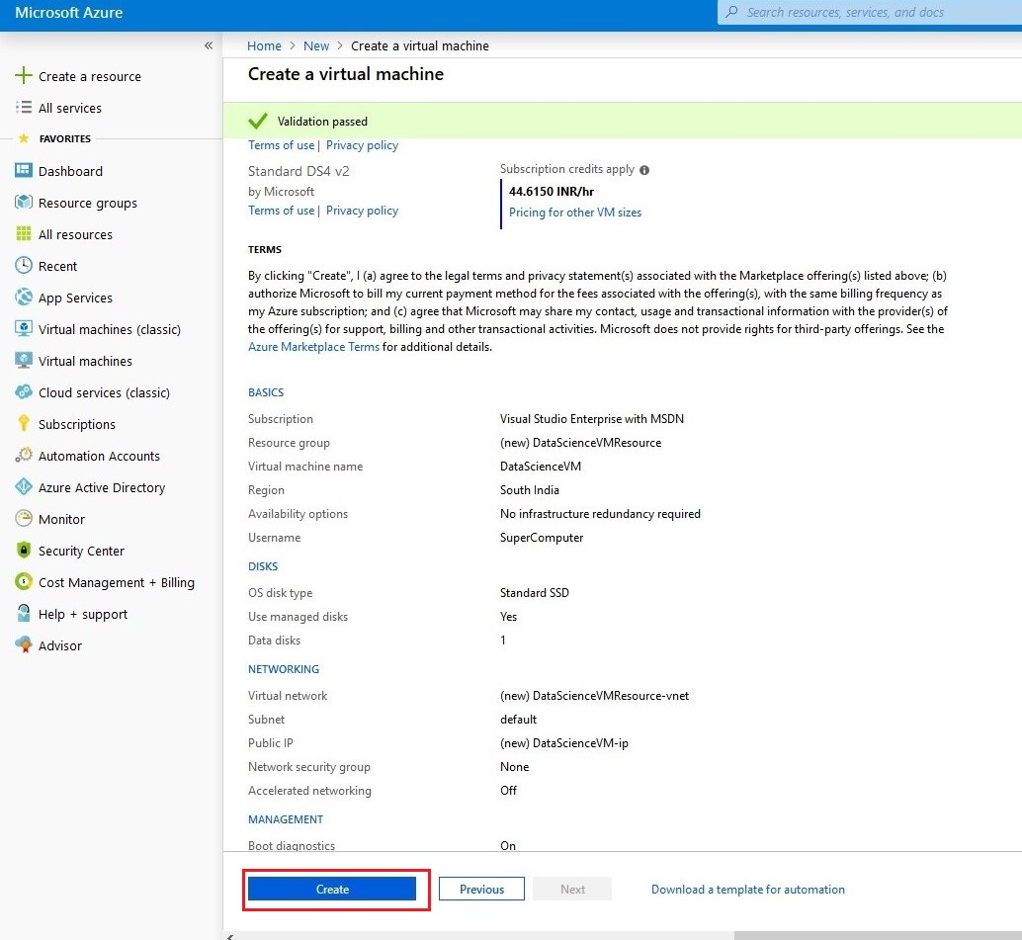

* After the Successful deployment, the dashboard and the notification bar show that our VM is deployed successfully. Then press button Go to resource for the "Overview" of your Data science VM.

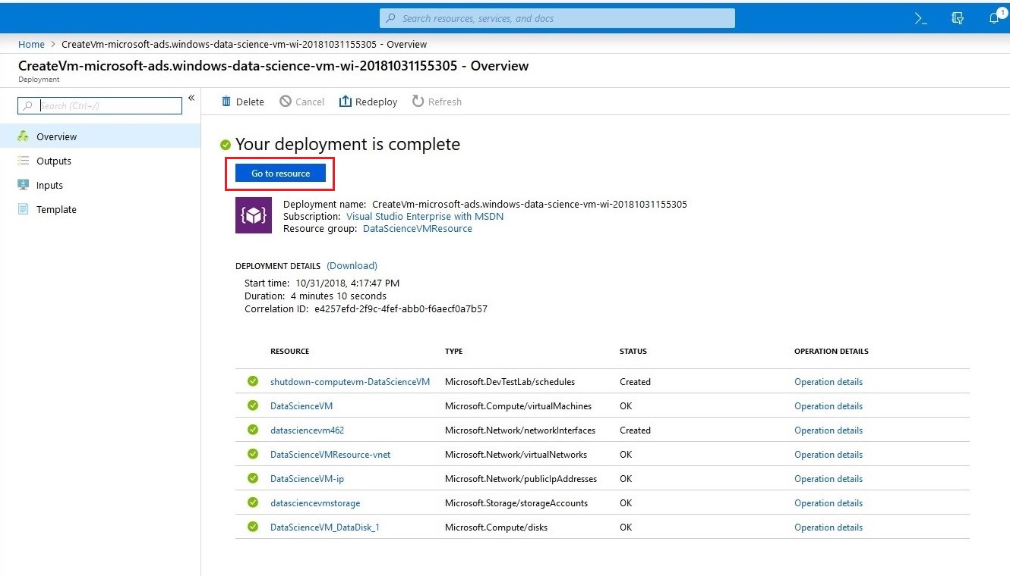

Step – 04:

* Follow the steps to connect the VM to our local machine. Open the deployed VM in dashboard and in the "Overview" tab press the connect bottom and then it downloads small (.rdp) file to connect our VM to our local machine.RDP file stands for Remote Desktop Protocol.

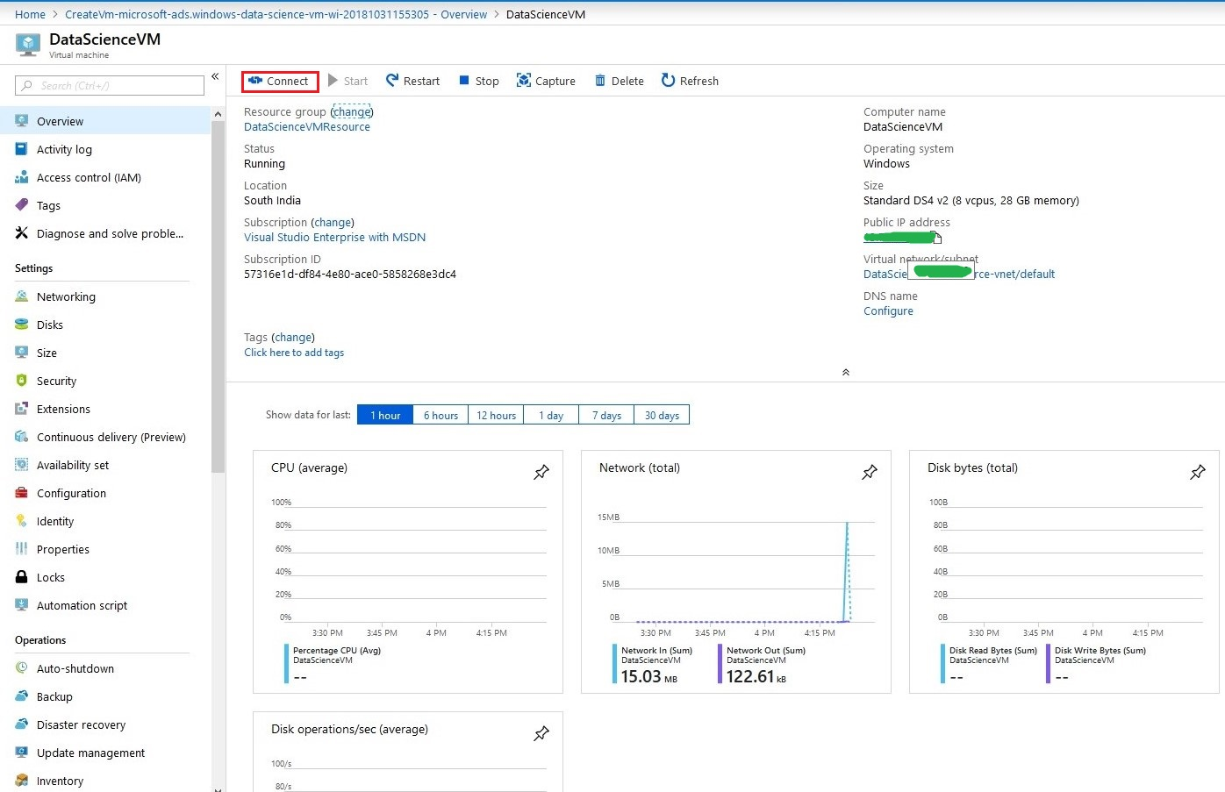

* Then use the user name and the password that we used in the creation of the VM to ensure the authorized person is accessing the VM and press OK to login into our VM.

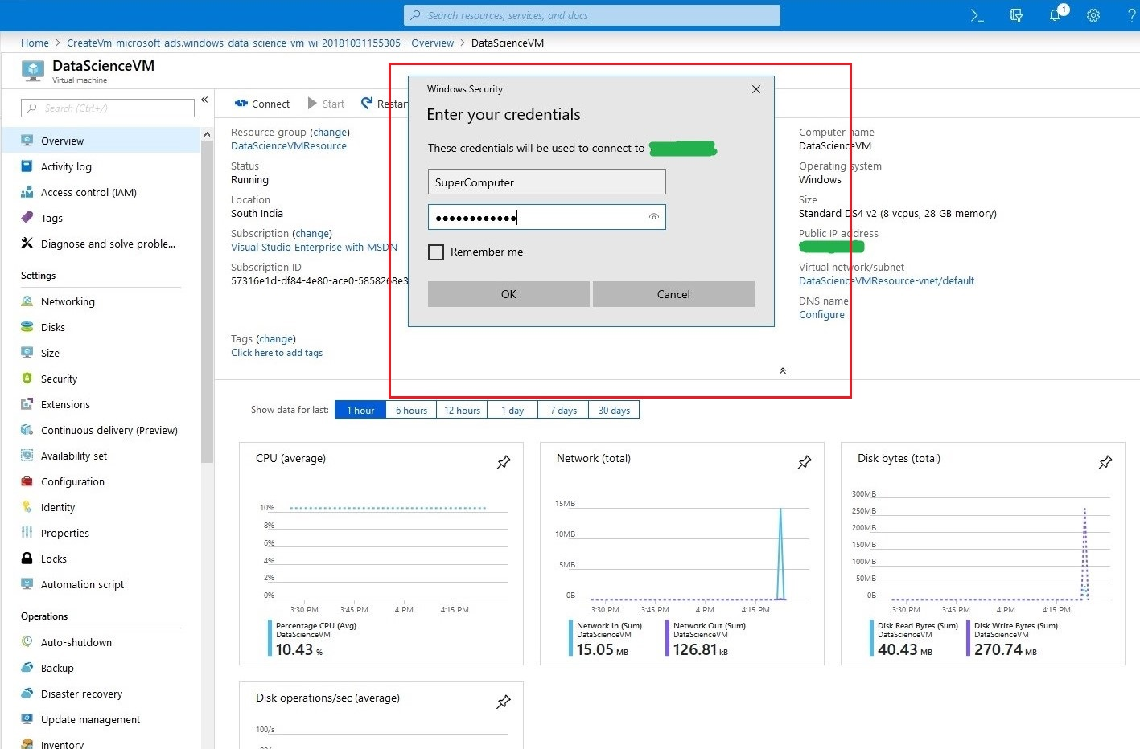

* Then it opens your Data science VM in our local System with the pre-installed programs for the professionals.
* Finally, we created the Data science virtual machine.

